Why do it Naked?

Today you can use C# for all types of applications from controlling robots and writing web apps to developing games and analysing data.  It runs on Windows and Mac in a variety of software including Visual Studio and the Unity Games Engine.

Though when you are learning to code for the very first time, when things go wrong, you can't be sure if it is you or the software. Doing away with all the bling leaves very little to troubleshoot when its just you, the code and the computer.

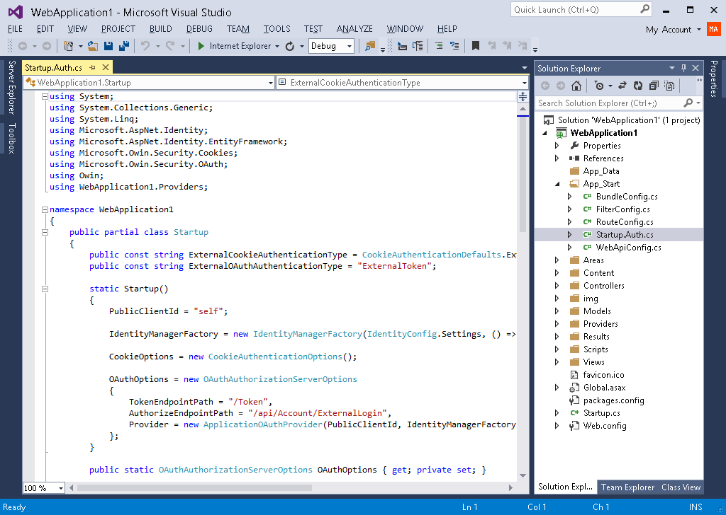

A C# Web Application in Visual Studio

In this course we strip all the fancy interfaces away to focus purely on programming.  Whether you are a Windows or a Mac person this course caters for all by using the **Sublime Text Editor** and the **Mono C# compiler**.  Lecture 3 will explain where to get this software from and how to install it.

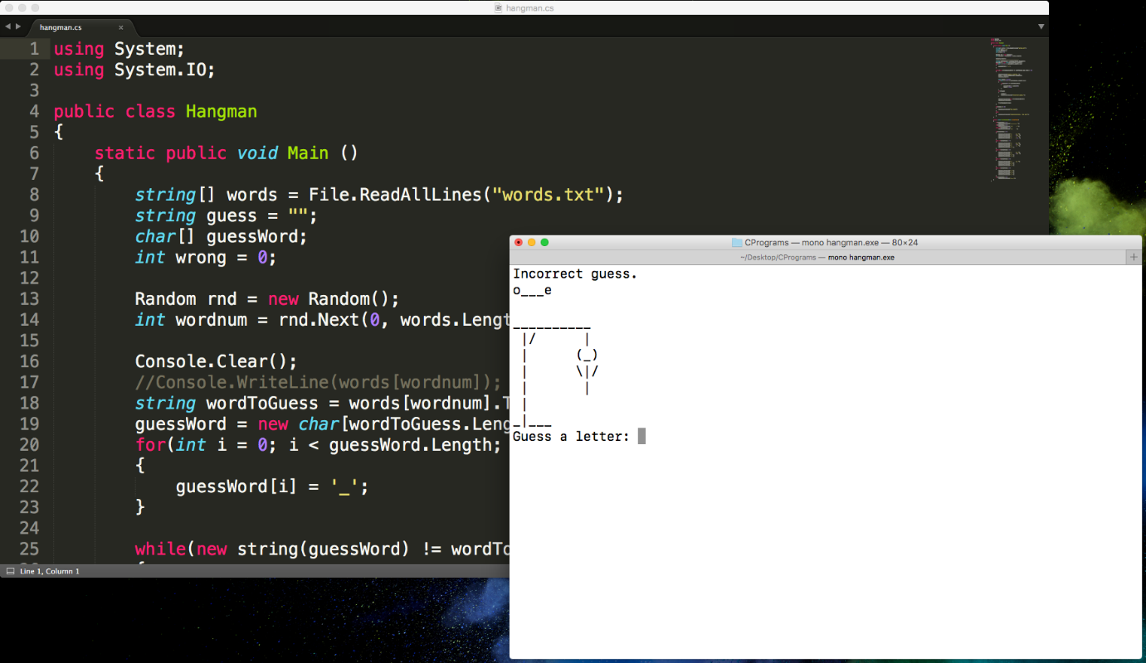

Hangman Game developed during this course in Sublime Text with Mono

We will be learning the **fundamental programming concepts** that exist in all coding languages.  When you have these under your belt you can be assured that switching between languages will become second nature.

I don't promise that you will come out of this course a programmer.  In fact you won't.  It takes at least 8 years of practice to get to that stage.  But if you are keen and committed the fundamentals you pick up in this course will take you far with programming into the future.

When you have these concepts locked down then it will be time to pick up the pretty tools and start creating.